Our Lady’s Grove Secondary School
Our Lady's Grove, Goatstown Road, Dublin 14

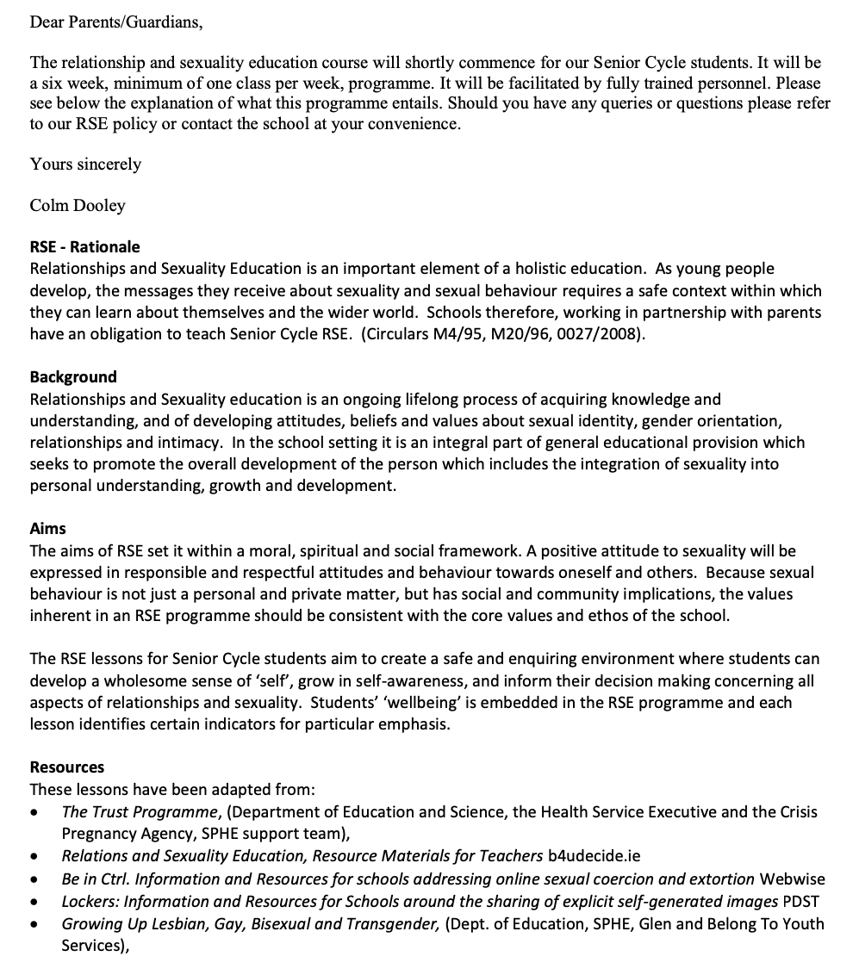

________________________________________________________________________________
Principal: Colm Dooley Deputy Principal: Sonya Lyons
Phone: 2951913 ♦ Fax: 2963597 ♦ Email: office@olgrove.ie

